IT2120 - Probability and Statistics

Lab Sheet 07

**IT24103653**

**Rodrigo H.A.D.A**

Exercise

01)



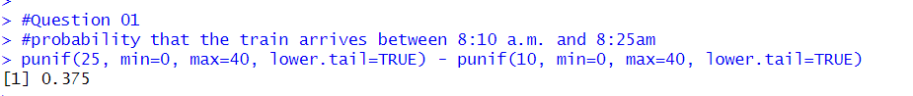

02)

03)

(i)

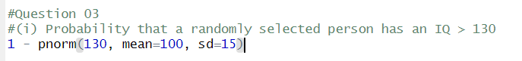

(ii)

